## Creating a Toolbox with Customized Python Script-based Tool

In ArcMap, open the ArcToolbox window. Right click on the main ArcToolbox and choose “Add Toolbox”.

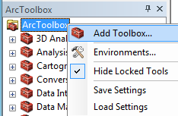

Create a new toolbox using the tool on the upper right of the dialog. Then give the toolbox a name and select “Open” to add it to ArcToolbox window.

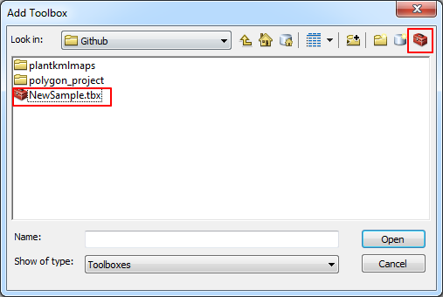

In the ArcToolbox window, right click on the new toolbox go to Add -> Script.

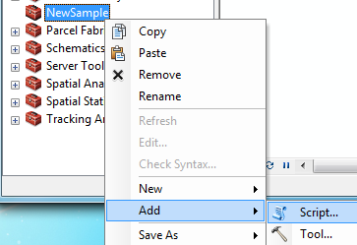

Give the script tool a name, label and description as desired. Make sure both the checkbox options are selected. Browse to where the script is located.

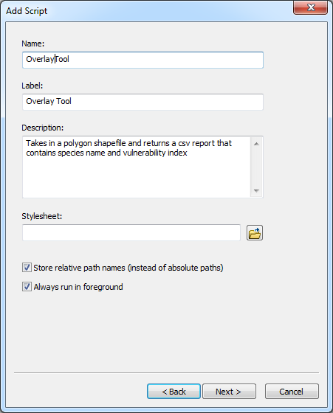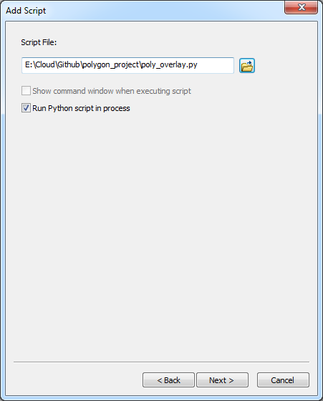

For each parameter, just start typing the name in an empty line. Select a data type from the drop down list next to each parameter. Each data type behaves differently on the tool interface. For the “Folder”, “File”, and “Shapefile” types, a browse button will appear next to the input textbox. The “String” data type defaults to a simple input textbox. The names given here are also the labels that will appear in the tool interface. Set the Type parameter for “Auxillary table…” to optional. Otherwise, all the defaults are fine for the parameters properties since they default to being an input.

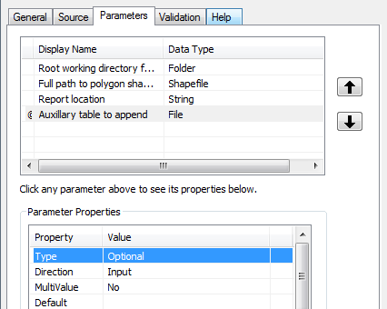

Once we’re finished, we need to go back in and make changes to get some defaults to behave correctly. Right click on the tool and select “Properties”. Go to the “Validation” tab and select the “Edit…” option. This should open Notepad (or your default text editor) with the script. (NOTE: I would copy the text to an IDE like PyScripter or Komodo to make sure the syntax and indentation are correct to avoid issues.)

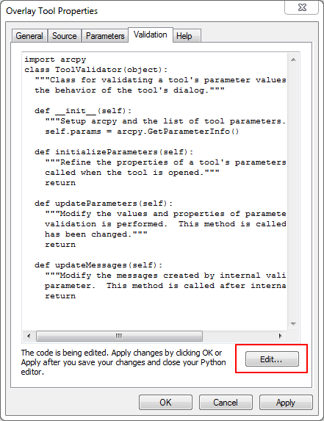

Under the def initializeParameters(self): section, you’ll want to add these lines. These

scriptDir = os.path.dirname(os.path.realpath(__file__))  
self.params[0].value = scriptDir  
if (len(scriptDir) == 3):  
 self.params[2].value = scriptDir + "protected_area_shapefile_folder\\protected_area_vulnerability_report.csv"  
else:  
 self.params[2].value = scriptDir + "\\protected_area_shapefile_folder\\protected_area_vulnerability_report.csv"

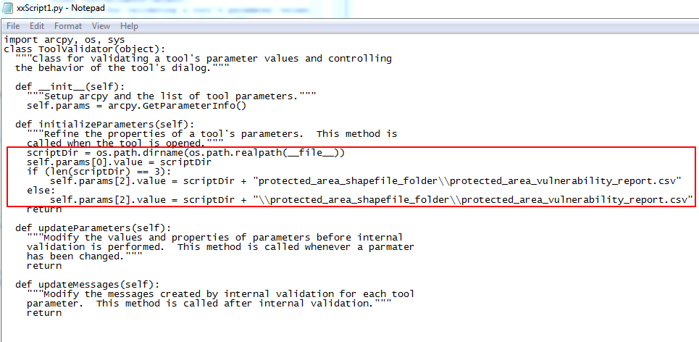

Line 2 should set the root folder parameter to match where the script is located.  
Line 3-6 should ensure that the output defaults to the name denoted and placed in the same folder as the script.  
When you’re done making changes, be sure to save in that Notepad session. That will commit it back to the toolbox.

To add help for the tool itself, go back to the ArcToolbox window, right click on the script tool and select “Item Description.”

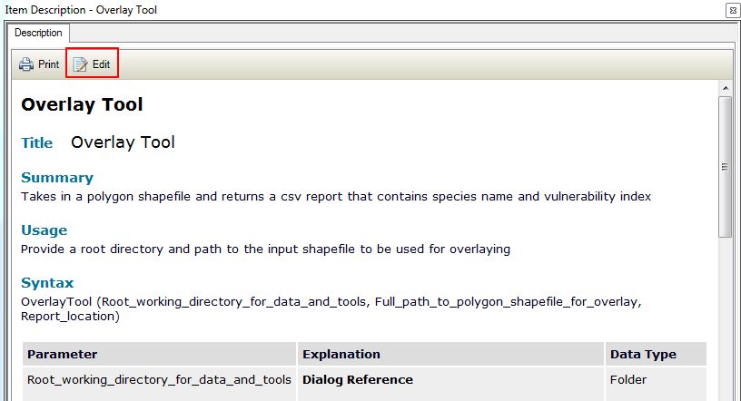

The form should resemble the metadata editing form.

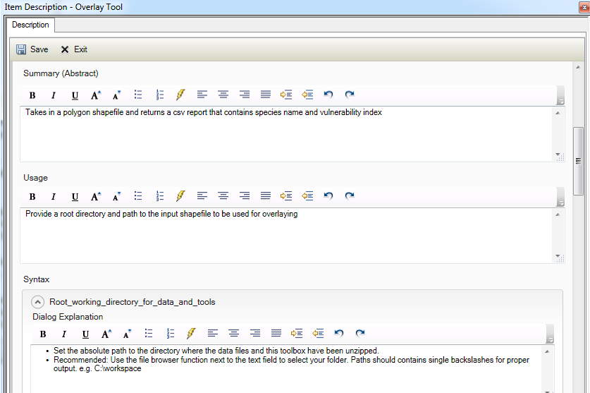

Edit the Dialog Explanation to add information to the Help menu for the tool’s parameters.

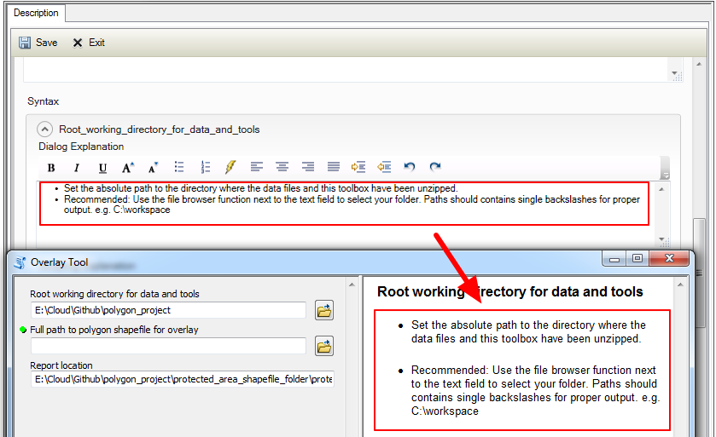

That’s likely the most useful of the fields for a user.

Remember to click the Save button to commit the changes.